|  |  |
| --- | --- |
| \\cetus.ece.missouri.edu\users\fischerjd\Desktop\Current Semester\common\logo-clear.png | University of Missouri – Columbia  Department of Electrical Engineering & Computer Science |

Solar Powered Lighting System for Outdoor Unpowered Structures

ECE 4980 Capstone Project  
Individual Contributions Report

April 14, 2021

— By —

Sterling LaBarbera, Computer Engineering

— Project Advisors —

Dr. Jae Kwon, PhD

Department of Electrical Engineering & Computer Science, University of Missouri

— Course Instructor —

Mr. Jim Fischer

# Abstract

The project for this paper is a lighting installation for unpowered outdoor structures. Its power source is a battery that charges via solar panel allowing for use at any structure with no main power access. Our intent for this project is to install it permanently at a structure, but it is portable if needed. The lighting is controlled using a Bluetooth capable device with an Android application. It can provide lighting for about four hours using a fully charged battery, and charges back to full in at least 4 days depending on weather. The lighting also features a music mode which takes audio inputs to produce a pulsed output based on volume, one of our main considerations for this project was use in a social event taking place at one of these structures. This paper describes my contributions, which are the power supply units, solar charging unit, and the user interface for the application. The power supply I designed was unsuccessful when integrated. The solar charging equipment was selected to meet the requirements of our project, and the user interface works well and is intuitive and simple.

***Index Terms*—Graphical user interface (GUI), Switched mode power supplies, solar power generation, voltage control.**

# Acknowledgements

See the instructions provided in the section “Acknowledgements” in the accompanying file Individual Contributions Report Instructions.pdf.

Table of Contents

Abstract i

Acknowledgements ii

Chapter 1.  Introduction 1

Report Purpose 1

Background 1

Individual Contributions Summary 1

Report Overview 1

Chapter 2.  Contributions 2

Chapter 3.  Timeline Analysis 3

Project Phases 3

Proposed Timeline 3

Actual Timeline 3

Chapter 4.  Conclusions 4

Successes 4

Limitations 4

Failures 4

Suggested Improvements 4

Appendix A.  Bill of Materials 5

Appendix B.  Source Code Listings 6

Appendix C.  Test Data 7

References 8

List of Illustrations

Figure 1. Full project diagram. 2

Figure 2. Functional block diagram for the project. 2

Figure 3.   Software architecture for the CONTROL assembly 2U5 (see also Figure 2). 3

Figure 4. Software architecture for the Smartphone 3U1 (see also Figure 2). 3

List of Tables

**No table of figures entries found.**

List of Equations

**No table of figures entries found.**

1. Introduction

## Report Purpose

This report documents my contributions to my group’s Capstone design project. Provided herein are detailed descriptions of each assembly and/or software element that I designed, created, tested, and integrated into the project.

A separate group report titled *Solar Powered Lighting System for Outdoor Unpowered Structures* establishes and documents the project-level information that (1) defines the project’s overall concept, specifications, and goals, (2) explains the project’s functionality and theory of operation, (3) describes the evaluation of completed project, and (4) documents the project’s outcomes.

## Project Overview

Figure 1 below shows the full project diagram. The solar panel generates power and sends it to the maximum power point tracker (MPPT). The MPPT sends voltage regulated power to charge the battery or power the connected device. The power supply takes the MPPT output and converts to two different lower voltage outputs for the LED strip and Arduino. These are separate due to current requirements for the strip exceeding the safe values for the Arduino. The Arduino takes inputs from the smart phone via Bluetooth and converts to the digital control signals going to the LED strip.

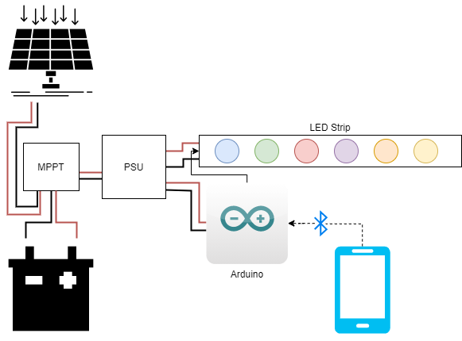

Figure 1. Full project diagram.

Figure 2 shows the functional block diagram for the full project. The parts in green are part of my contribution.

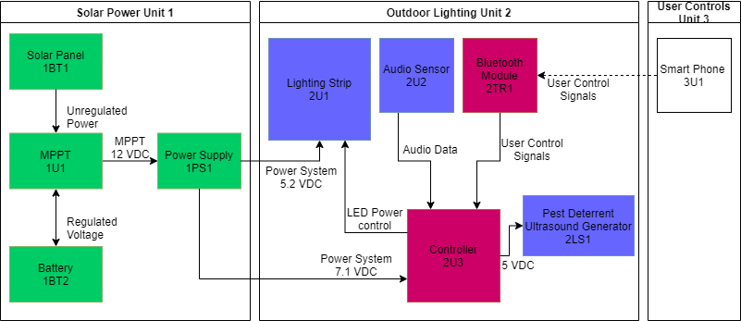

Figure 2. Functional block diagram for the project.

The Solar Panel 1BT1 is 100 W and provides unregulated power to a maximum power point tracker (MPPT) 1U1. The MPPT then regulates that power to 12 VDC to charge the connected Battery 1BT2 and also provides the output from the battery for any connected device, in this case, the power supply unit (PSU) 1PS1. The PSU consists of two switched mode power supplies in parallel. One converts the input to a 5.2 VDC output for the lighting strip 2U1, and the other converts to a 7.1 VDC output for the Controller 2U3. The controller receives input from the user via the Bluetooth module 2TR1 and controls the lights’ brightness and colors. It also receives audio data via the audio sensor 2U2 when in music mode. The pest deterrent ultrasound generator 2LS1 draws power through the controller and produces a high frequency tone to deter certain pests. Finally, the smart phone 3U1 sends user control signals via Bluetooth that are processed by the controller.

Figure 3 and Figure 4 show the software architecture for the microcontroller and smartphone. My contribution is the LED Output Controls

|  |  |  |
| --- | --- | --- |
| Control Assembly – 2U3 | | |
| LED Output Management | | Remote Connection |
| LED Power Control | Audio Data | User Control Signals |

Figure 3.   Software architecture for the CONTROL assembly 2U5 (see also Figure 2).

|  |  |  |
| --- | --- | --- |
| Smartphone – 3U1 | | |
| Mobile Interface | | |
| LED Output Control | Bluetooth Connection Manager | Music Mode |

Figure 4. Software architecture for the Smartphone 3U1 (see also Figure 2).

The control assembly runs on the controller 2U3 and takes user control signals from the application (app) on the smartphone. It is remotely controlled by the smartphone via Bluetooth. The app uses the Bluetooth connection manager to pair with the Bluetooth module on the controller. The LED output controls on the phone provides color controls, brightness adjustment, and 2 different predefined modes of operation which are toggled on and off from the app. Music mode takes audio data and pulses the lights to the music based on volume. Flow mode slowly fades between preset colors. LED power control is the digital output to the LED strip providing control signals for LED brightness.

## Individual Contributions Summary

I worked on Unit 1 which contains the power elements of the project, and the user interface (UI) for the smartphone app. The solar panel 1BT1, MPPT 1U1, and battery 1BT2 were all purchased. I worked on development for power supply 1PS1 to provide the two different constant voltage outputs for controller 2U3 and lighting strip 2U1. For the Mobile Interface, I developed the LED output control which is the UI for the app.

## Report Overview

Following this introduction, Chapter 2 gives a detailed description of my individual contributions to the project including the assumptions made, conception, and theory of operation. Chapter 3 provides a timeline analysis of my contributions comparing the actual dates to the proposed timeline from the first semester. In chapter 4, I summarize the results I obtained and expand on what can be done to improve these elements given more resources. I will also cover the limitations to my approach to the power supply.

The end of this report consists of Appendix A bill of materials, where I give a table of purchased items for my contributions; Appendix B, which contains a code listing for the UI section of the smartphone app; and Appendix C which has the test data from the PSU development. The final element has citations for all the research I used during development.

1. Contributions

<DELETEME>

Write a short statement that informs the reader of this chapter’s purpose and contents.

See the instructions provided in the section “Chapter 2 - Contributions” in the accompanying file Individual Contributions Report Instructions.pdf.

</DELETEME>

1. Timeline Analysis

<DELETEME>

Write a short statement that informs the reader of this chapter’s purpose and contents.

See the instructions provided in the section “Chapter 3 – Timeline Analysis” in the accompanying file Individual Contributions Report Instructions.pdf.

</DELETEME>

## Project Phases

## Proposed Timeline

## Actual Timeline

1. Conclusions

<DELETEME>

Write a short statement that informs the reader of this chapter’s purpose and contents.

See the instructions provided in the section “Chapter 4 – Conclusions” in the accompanying file Individual Contributions Report Instructions.pdf.

</DELETEME>

## Successes

## Limitations

## Failures

## Suggested Improvements

Bill of Materials

<DELETEME>

Write a short statement that informs the reader of this appendix’s purpose and contents.

See the instructions provided in the section “Bill of Materials Appendix” in the accompanying file Individual Contributions Report Instructions.pdf.

</DELETEME>

Source Code Listings

<DELETEME>

Write a short statement that informs the reader of this appendix’s purpose and contents.

See the instructions provided in the section “Appendices – Source Code Listings Appendix” in the accompanying file Individual Contributions Report Instructions.pdf.

EXAMPLE.

Listing 1. Source code for the C++ program “Hello, World!” (hello.cc).

#include <iostream>

using namespace std;

int main()

{

cout << "Hello, World!" << endl;

return 0;

}

</DELETEME>

Test Data

<DELETEME>

Write a short statement that informs the reader of this appendix’s purpose and contents.

See the instructions provided in the section “Test Data Appendix” in the accompanying file Individual Contributions Report Instructions.pdf.

</DELETEME>

# References

<DELETEME>

See the instructions provided in the section “References” in the accompanying file Individual Contributions Report Instructions.pdf.

</DELETEME>